**Assignment #2**

Our calculations were made in Python, the code is attached in a notebook file.

Question 1 – Linear Models and Bootstrapping

1. *Linear regression model:*  
   The estimated value for the slope and intercept that we've found are as follows:  
   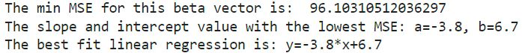

Figure 1:   
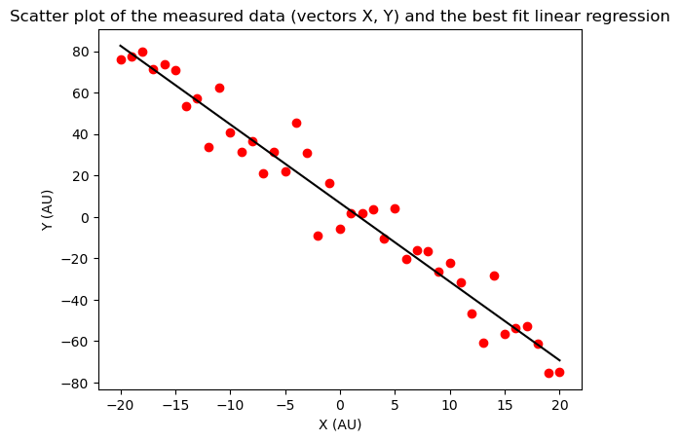

Estimating the STD of the noise distribution: In our case, the noise is defined as the difference between the predicted and measured values. So, we've calculated a distribution of those differences and its STD (here we're dealing with a sample and not a population, therefore the df=n-1).   


1. *Bootstrapping:*

Figure 2: Histograms of the best slope and intercept estimates for 1000 generated samples

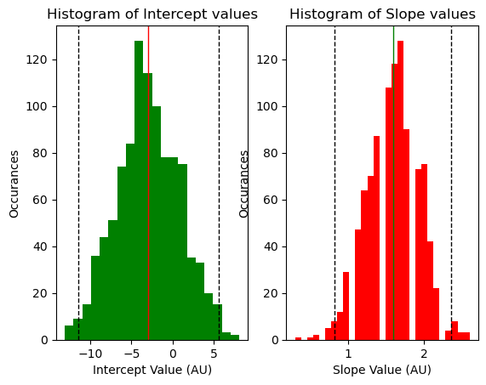

The average value for the estimated slopes is 1.58 , and -2.75 for the intercepts, as is denoted by the solid line in Figure 2.  
  
Answer for bonus: the dotted lines in Figure 2 represent the 97.5% CI for each distribution.



Question 2 – GLM

The set of parameters :[(17,6,**-**19,48),(1,4,**-**7,1),(3,0.02,0.1,**-**1)] the LL values are presented in a corresponding order.

1. To find the best set of parameters , we need to calculate the log likelihood of each set and chose the set with the highest LL value.
2. This regularization factor "punishes" high values. After adding the regularization factor  
   as we can see, the LL values changed but the set with the highest one remains the same – the answer didn't change.
3. To set up the Poisson regression, we've used a *Log* link function (the default of the Poisson family in *statsmodels* GLM) and a noise distribution from the *Poisson-family*.  
   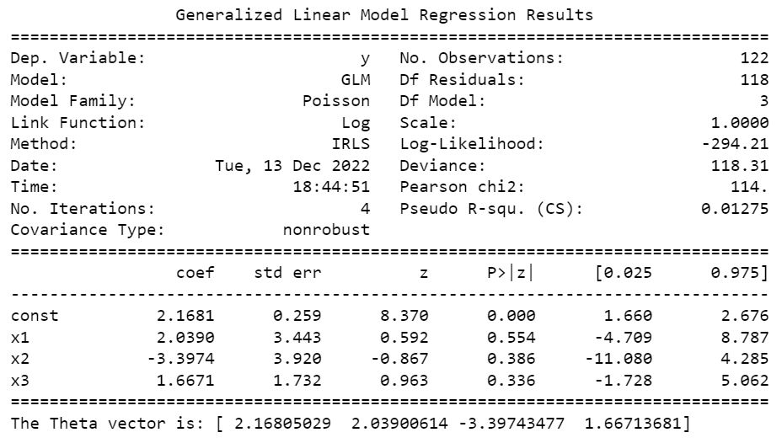



1. The first value is the intercept. From the rest, as we're told that the X values are neurons: X1, X2, X3 influencing our neuron's Y FR. Therefore, we can infer that negative values represent inhibitory inputs while positive ones represent excitatory inputs.  
   X1 is excitatory, X2 is inhibitory and X3 is excitatory as well. Furthermore, neuron X2 has the highest influence on Y's FR, as it has the highest absolute coefficient value.